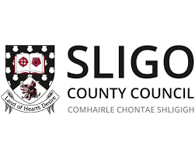
PEACE IV Team
Sligo County Council
City Hall
Quay Street
Sligo
Tel: 071 9114423

Project Name: …………………………………………..…… Ref:……………

Organisation Name: ……………………………………………………………………

Address: ……………………………………………………………………

Telephone: ……………………………………………………………………

CLAIM DECLARATION BY PROJECT PROMOTERS
Project Reference
Project Title
Claim Reference
Claim Submission Date
Amount included in this Claim

Declaration

I hereby declare that the expenditure detailed in this claim has been incurred and paid for solely for the purpose of the approved project in accordance with the terms and conditions of the letter of offer dated …………………………. (insert date of LOO) and in full compliance with the relevant EU and national regulations governing this project and in accordance with programme guidance issued by SEUPB.

I confirm that all original project documentation will be retained as required under the terms of the letter of offer for verification and for any subsequent audit purposes.

Signed : ………………………………………………… Date: ……………….

Name: …………………………………………………

Position: …………………………………………………

(This declaration must be signed by one of the Letter of Offer signatories.
A printout of the submitted claim form should be attached. Please submit this and an invoice for payment to Sligo Peace IV Team at the above address)

