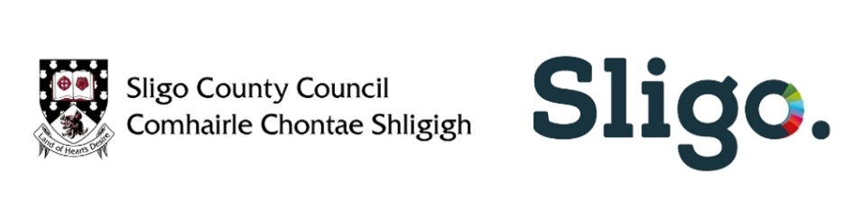
Local Live Performance Programming Scheme 2022 – Phase 4
Open call for Proposals
Please read the Guidance Notes for the Scheme before completing this form
PART A – Applicant Details
- Contact Details
(Please note that all payments will be paid to the applicant named here and it must match the name on your bank account)
Applicant |  | Contact Person
Address |  | Telephone
 |  | Mobile
 |  | Email
 |  | Website

- Bank Details
(For the purpose of paying the grant, the name on the bank account must match the name of the applicant)
Name on Bank Account |  | Account Number
Name of Bank |  | Bank Sort Code
Address of Bank

3. People involved in programming and managing your proposed event.
Please provide details of all people involved in programming and managing the event you are proposing.
Applicants must nominate an ‘Event Organiser’ who will be the person that has overall responsibility for managing the event.
Applicants must nominate the person responsible for Health & Safety (Inc. Covid planning).
If the event includes performances by children, or events specifically for children, please also identify who is responsible for the groups Child Protection Policy.
Please indicate if these roles are being paid or voluntary roles.
Name | Role and description of Duties | Voluntary or Paid role
PART B – Event Description
(Please attach additional programme details separately, as necessary)
1. Title of the Event

2. When and where will the events happen? Please note that all events must be complete by October 31st 2022.

3. Please provide details of the proposed programme/event. This should include details of the performers who will be part of your event. Applications will be assessed on the content provided here and while ambition and innovation are encouraged, we advise organisers to propose activities that they have the capacity to deliver.

4. The core objective of the programme is to support local professional artists/performers and production and technical crew involved in the live performance industry. In this context ‘local’ is taken to mean those professionals that are from or living in County Sligo.
Please list all individuals that will receive payment through these events, indicating their role and where they are currently based.
It is acknowledged that while the purpose of the scheme is to support local artists/performers and production and technical crew, for artistic reasons it may be necessary to engage individuals from elsewhere and that a band for example may have some members from Sligo while others are based elsewhere. It may also be the case that essential technical or production services cannot be sourced locally.
*Note: The proposed event/series of events can only take place within County Sligo.
Name | Role (actor, sound engineer etc.) | From (County)

B5. Who is your target audience?

B6. Please provide details of any previous experience of managing similar events.

PART C – Budget
Please note that for this phase, funding will be provided for live events only.
All events should be free of charge.
There is no requirement to have any match funding and all eligible costs related to these events may be funded through the scheme. Where events have secured additional funding/sponsorship this must be detailed in your application and an outline of how LLPPS funding will be used to add value to your event. Please include this information in your budget.
All professional artists should be paid in line with the Art Council’s policy for fair pay for artists. At least 20% of your overall budget must be spent on fees for performers.
In devising your budget, please consider the following: professional artist/performer fees; technical and event production costs; venue costs (indoor or outdoor); insurance; health and safety; security; marketing/promotion; booking management etc.
Please remember that events at this time may have additional event management costs and may require additional personnel and infrastructure, in-line with current public health guidelines.
Please ensure that you have read the guidance notes and are clear about eligible/ineligible costs, prior to submitting a proposal for funding.
Grant funding should not be used as top up or substitute funding for existing events. Groups & Organisations already in receipt of funding from Sligo County Council will need to provide information in relation to this and demonstrate that the activity proposed under the LLPPS – Phase 4 is separate and distinct and not already supported/subverted by Sligo County Council.
- Please outline below any funding you have applied for/received from Sligo County Council to date this year.

- Please outline clearly how the activity in this proposal is separate and distinct from the activity already supported through the funding above:

- Please complete the budget details in the LLPPS Budget Template.

PART D – Enclosures
Required
Evidence of adequate and comprehensive Public Liability insurance (with an indemnity to Sligo County Council and the Dept of Tourism, Culture, Arts, Gaeltacht, Sport and Media)
or
A statement confirming that should you be awarded the grant; you are willing and able to raise insurance cover to these levels (in cases where the existing cover levels are lower) and that you will maintain these levels for the duration of the event.
Optional
- More comprehensive programme, schedule or budget information.
- Biographies of artists / performers / groups that you plan to engage.
- Examples of other events the applicant has organised/delivered

PART E - Declaration
Signature _______________________________________________
Printed Signature _______________________________________________
Date _______________________________________________

Please tick to confirm that you have read the Guidance Notes for the LLPPS Scheme Phase 4

Please submit completed applications along with any additional information by email only to festivalgrants@sligococo.ie with the name of the applicant in the subject line.
For further information please contact festivalgrants@sligococo.ie

Closing date for receipt of applications is 4.30pm on
Thursday 14th July 2022

